|  |
| --- |
| Indigo Central Issuing: Bulk Card Request |
| Technical Specification: Indigo ver. 2.1.0.0 |
| draft |

**Confidentiality**

This document is the confidential property of Veneka (pty) ltd, and is supplied under the terms of an agreement with Veneka. It may not be disclosed or used except as is permitted by the agreement or as may be expressly permitted by Veneka (pty) ltd.

All registered or unregistered trademarks and service marks are properties of their respective companies and should be treated as such.

|  |  |  |  |
| --- | --- | --- | --- |
| Version. | Author | Changes | Release Date |
| Draft | Moleboheng Tladi |  |  |
|  |  |  |  |
|  |  |  |  |
|  |  |  |  |

Table of Contents

1 Introduction 6

2 Requirements 6

2.1 Issuer Code 6

2.2 Product Code 6

2.3 Request Reference Number 6

2.4 Branch Code 6

2.5 Customer First Name 7

2.6 Customer Middle Name 7

2.7 Customer Last Name 7

2.8 Customer ID 7

2.9 Name on Card 7

2.10 Title 7

2.11 ID / Passport Number 8

2.12 Resident / Nationality 8

2.13 Customer Type 8

2.14 Reason for Issue 8

2.15 Account Number 8

2.16 Account Type 8

2.17 Account Currency 9

2.18 Priority 9

2.19 Order Date 9

3 Processing Logic 10

3.1 Card Request Configuration 10

3.2 File Upload 10

3.3 Create Load Batch 10

3.4 Create Production Batch 10

4 Database 11

4.1 Tables 11

4.2 Stored Procedures 11

5 Screens 13

5.1 Issuer Admin Screen 13

5.2 Dist Batch List Screen 13

# Introduction

This is a technical specification for the implementation of bulk card requests via file uploads.

# Requirements

Cards will be uploaded per request and the following validations will be done on the provided information and field lengths.

## Issuer Code

|  |  |
| --- | --- |
| Description | Issuer code for the file to be uploaded |
| Example | Bank99 |
| Notes |  |
| References |  |
| Related Rules | * Verify Issuer is configured in Indigo * Validate issuer has bulk card request uploads enabled |
| Assumptions |  |

## Product Code

|  |  |
| --- | --- |
| Description | Product Code of the card requests |
| Example | GLD01(Gold Card) |
| Notes |  |
| References |  |
| Related Rules | * Verify the product is in the system * Verify the product is enabled * Verify the product is licensed * Verify the product is configured for bulk uploads * Verify the product is configured for centralised issuing |
| Assumptions |  |

## Request Reference Number

|  |  |
| --- | --- |
| Description | The unique reference number for each card request from the originating system. |
| Example |  |
| Notes |  |
| References |  |
| Related Rules |  |
| Assumptions | The system where the request originates from has validated the reference number. |

## Branch Code

|  |  |
| --- | --- |
| Description | Branch code as configured in Indigo |
| Example | TES002 |
| Notes |  |
| References |  |
| Related Rules | * Validate the branch is in the system * Validate the branch is active? * Validate the branch is configured for this issuer |
| Assumptions |  |

## Customer First Name

|  |  |
| --- | --- |
| Description |  |
| Example |  |
| Notes |  |
| References |  |
| Related Rules |  |
| Assumptions |  |

## Customer Middle Name

|  |  |
| --- | --- |
| Description |  |
| Example |  |
| Notes |  |
| References |  |
| Related Rules |  |
| Assumptions |  |

## Customer Last Name

|  |  |
| --- | --- |
| Description |  |
| Example |  |
| Notes |  |
| References |  |
| Related Rules |  |
| Assumptions |  |

## Customer ID

|  |  |
| --- | --- |
| Description |  |
| Example |  |
| Notes |  |
| References |  |
| Related Rules |  |
| Assumptions |  |

## Name on Card

|  |  |
| --- | --- |
| Description |  |
| Example |  |
| Notes |  |
| References |  |
| Related Rules |  |
| Assumptions |  |

## Title

|  |  |
| --- | --- |
| Description |  |
| Example |  |
| Notes |  |
| References |  |
| Related Rules |  |
| Assumptions |  |

## ID / Passport Number

|  |  |
| --- | --- |
| Description |  |
| Example |  |
| Notes |  |
| References |  |
| Related Rules |  |
| Assumptions |  |

## Resident / Nationality

|  |  |
| --- | --- |
| Description |  |
| Example |  |
| Notes |  |
| References |  |
| Related Rules |  |
| Assumptions |  |

## Customer Type

|  |  |
| --- | --- |
| Description |  |
| Example |  |
| Notes |  |
| References |  |
| Related Rules |  |
| Assumptions |  |

## Reason for Issue

|  |  |
| --- | --- |
| Description |  |
| Example |  |
| Notes |  |
| References |  |
| Related Rules |  |
| Assumptions |  |

## Account Number

|  |  |
| --- | --- |
| Description |  |
| Example |  |
| Notes |  |
| References |  |
| Related Rules |  |
| Assumptions | CMS validates the account number |

## Account Type

|  |  |
| --- | --- |
| Description |  |
| Example | Valid Account type of account number. Possible values are:  Current = 0  Savings = 1  Cheque = 2  Credit = 3  Universal = 4  Investment = 5 |
| Notes |  |
| References |  |
| Related Rules |  |
| Assumptions |  |

## Account Currency

|  |  |
| --- | --- |
| Description |  |
| Example |  |
| Notes |  |
| References |  |
| Related Rules |  |
| Assumptions |  |

## Priority

|  |  |
| --- | --- |
| Description |  |
| Example |  |
| Notes |  |
| References |  |
| Related Rules |  |
| Assumptions |  |

## Order Date

|  |  |
| --- | --- |
| Description |  |
| Example |  |
| Notes |  |
| References |  |
| Related Rules |  |
| Assumptions |  |

# Processing Logic

## Card Request Configuration

1. The administrator will configure the file path for the interface in the interface screen
   1. Find the file path for the card request file to be uploaded in the database configuration for the particular issuer using the Integration Guid.
2. The Issuer Admin will select the interface configured per issuer
3. Card Request Processor should check the integration for all the file loader dll’s.
4. According to the file loaders setup in the integration the File Processor will loop through all the configured issuers and find the files with the configured file paths.
5. File processing job will run intermittently and process files in defined locations.
6. Once the processing job completes uploading the files, it should move the files to a different location for processed files.

## File Upload

|  |  |
| --- | --- |
| Description | Load Delimited File from File System (As configured in the integration, per issuer) |
| Example | C:\Veneka\Indigo\FileLoader*[issuer]*_*[productcode]*.txt |
| Notes |  |
| References |  |
| Related Rules | * File Loader Interface must be configured per Issuer * Each file should have one product. * Valid and Licensed Issuer * Valid and Licensed Product – Centralised Issuing product * Valid and Licensed Branches in file |
| Assumptions |  |

## Create Load Batch

|  |  |
| --- | --- |
| Description | Once the card request files have been loaded into card request objects by the file system, they are sent for approval by the Card Centre Manager |
| Example |  |
| Notes |  |
| References |  |
| Related Rules | * Number of files uploaded must equal the numbers of valid card request objects. * Depending on whether the issuer has auto-approve batch enabled, the process will create a production batch and await approval. |
| Assumptions | The approval of a load batch will always go to production batch. |

## Create Production Batch

|  |  |
| --- | --- |
| Description | Creates a card request batch for production of centralised issuing cards. |
| Example |  |
| Notes |  |
| References |  |
| Related Rules | Created when Load Batch has been approved. It will create a batch with status “Approve_For_Production” |
| Assumptions | One batch created includes all the branches contained in File Upload file. |

# Database

## Tables

1. Created new table load_batch_types
2. Added a column to load_batch: load_batch_type_id (default value is 1 – normal file load)



## Stored Procedures

1. Create Load Batch – *[sp_create_load_batch_bulk_card_request]*
   1. Insert the file history – *[sp_insert_file_history]*
   2. Insert the load batch – *[sp_insert_load_batch]*
   3. Insert the load batch status – *[sp_insert_load_batch_status]*
   4. Do an insert per record: Add a card record with an empty card number, the card reference number will be generated later in the process. – insert *[cards]*
   5. Generate card reference and update card with reference number – update *[cards]*
   6. Save customer details to Customer Account and wait for the batch to be approved for production – *[customer_account]*
   7. Insert the records into load batch – *[load_batch_cards]*
2. Approve Batch – *[sp_load_batch_approve]*
   1. Verify the load batch type is “card request file” – *[load_batch_type]*
   2. Create the production batch – *[dist_batch]*
   3. Add cards to production batch – *[dist_batch_cards]*
   4. Get the number of cards inserted and add production batch status – *[dist_batch_status]*
   5. Generate a batch reference number for audit purposes – Concatenate *[issuer_code] , [product_id], [current_date]* and *[dist_batch_id]*
   6. Update the branch card status for the cards added – *[branch_card_status]*
   7. Check if auto-approve is enabled, if so add an approved status – *[dist_batch_status]*
   8. Update the load batch status to Approved – *[load_batch_status]*
   9. Log the auditing information. – *[sp_insert_audit]*

# Screens

## Issuer Admin Screen

* Changed the distribution batch auto – approve option to be available for centralised issuing.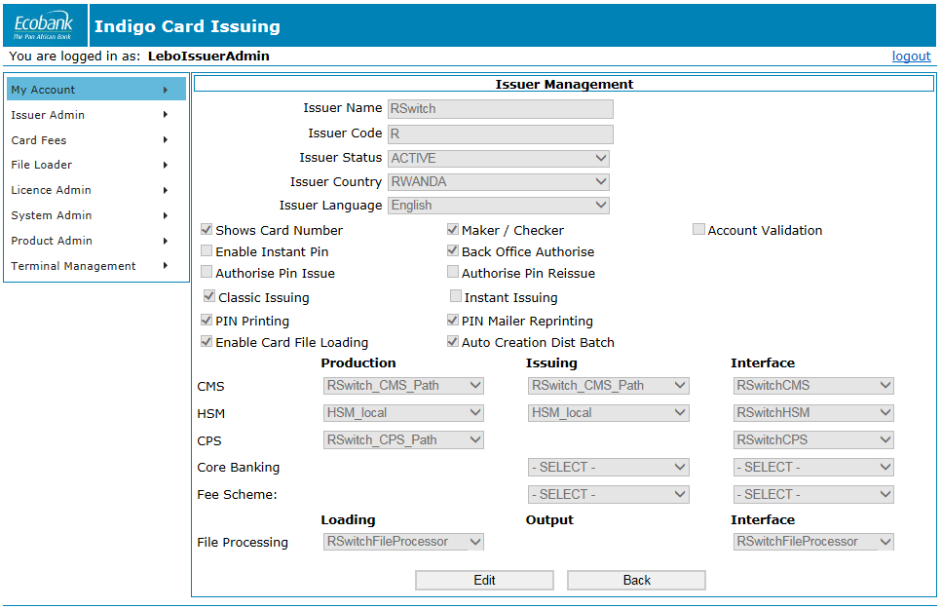

## Dist Batch List Screen

* 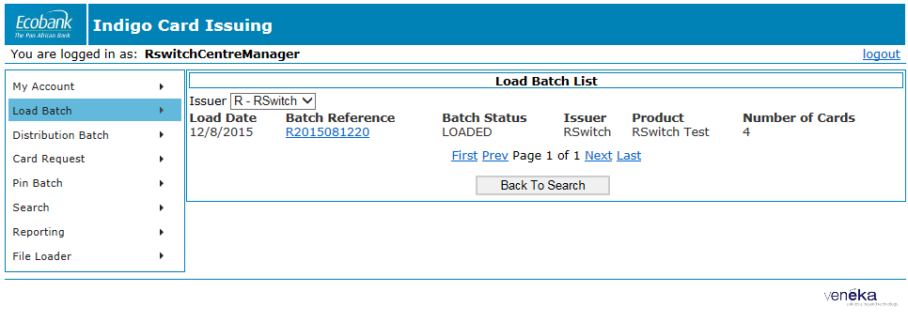Removed a column for Branch Name
* Added a column for Issuer Name and Product Name.